

**CUKUROVA UNIVERSITY – COMPUTER ENGINEERING**

**ALGORITHMS AND PROGRAMMING LAB.**

**PROJECT REPORT**

Nükte ÖZKILINÇ 2019556456

Elmas BAYRAM 2018556011

Gazel ELARYANİ 2018556303



Our project is writing code to run The Laser Box. Laser Box is a puzzle game that offers a lot of various elements for controlling the laser beam. The aim of the game is to get through obstacles and direct the laser beam to the designated areas. In our project we design the first two level.

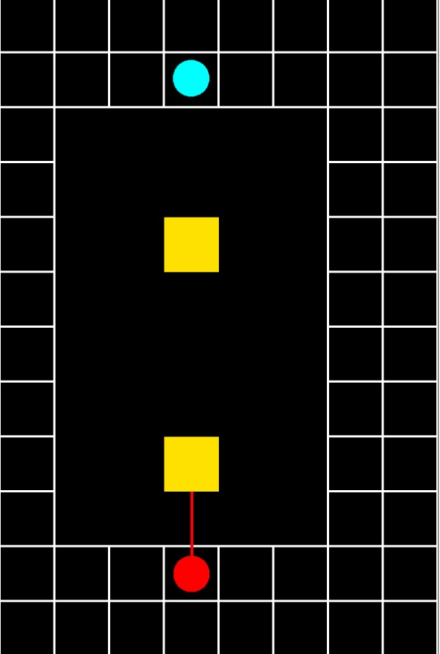

In the first level, there are two obstacles which are two yellow squares. These squares cut off the beam, when touched. So, you have to move squares from the laser beam path with a mouse ( *one of the squares moves by clicking on the right button and the other one by clicking on the left button.*) Therefore, the laser beam guide the right place ( *blue circle*) offer that you win the first level. We had a hard time moving the mouse while designing the first level. At the last, we watched videos that about Allegro Library, a lot of times and we were able to figure out the problem. On the other hand , we easily drew circle and squares. We researched their colors on the internet and we decided their position one by one.

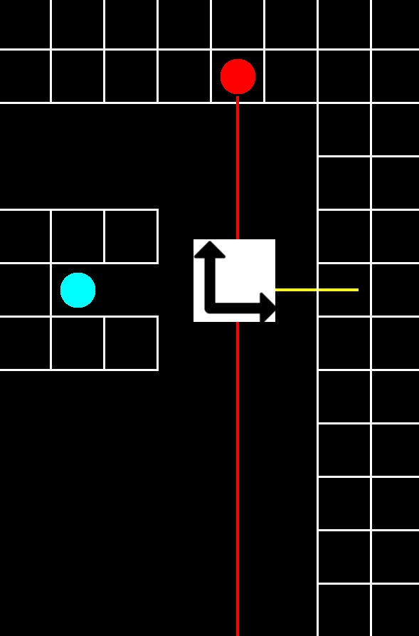

In the second level there is a moving square that you can move in all of the directions. Below, upper, left and right in order to let the laser beam pass and hit the designated areas (*blue circle*).



The part we had difficulty in this level was to ensure that the square we moved guided the laser in certain roads. We watched various related videos and solved our problem. The part we did not have difficulty in was to add the photograph of the square that guides the laser to the code and make it rotate 90 degrees by clicking the right mouse button.

Finally, when we finish the two level, we started to think about fine details. For instance;

1. Close the tab from the close button.
2. Pressing the space button to play.
3. Press esc key to exit the game.

Being in this project taught us to adapt to teamwork and to apply what we learned.